# Problem 3. Regexmon

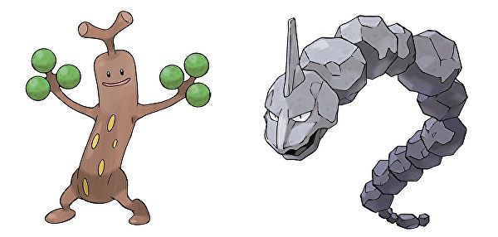Bojomon and Didimon are both pokemons which like to capture specific elements from a text. But they always fight so they decided to take turns in capturing things. Didimon is **first**, of course, because “ladies first”.

**Bojomon** matches only **pokewords**.   
A **pokeword** consists of **2 sequences** of **alphabet letters**, separated by a **dash** (‘-’). **Example**: “pika-pika”

**Didimon** matches everything **EXCEPT** **alphabet letters** and **dashes**.

You will get a **single string**, containing random ASCII characters, from the input.

**Didimon starts first**. If she **finds** a **match**, she prints it on the console, and **switches** **turns** with Bojomon.

Then Bojomon starts matching **AFTER** **Didimon’s match**, **IGNORING** everything **before** it, from the string. When he finds a match, he prints it and **switches turns** with **Didimon**, and she starts matching **AFTER** Bojomon’s match.

This process **repeats** until **the one** who is **at turn** does **NOT** match **anything** till the end of the string.

**Example**: “!!!aa-aa?_?”

1. **Didimon** matches “!!!”, then she **switches** with Bojomon.
2. Bojomon **starts after Didimon’s match** and so he has “aa-aa?_?”. He matches “aa-aa” and **switches** with Didimon.
3. Didimon **starts after Bojomon’s match** and so she has “?_?”. She matches “?_?” and **switches** with Bojomon again.
4. Bojomon **starts after Didimon’s match** and so he has “” (**empty string**). He matches **nothing** and the program **ends**.

### Input

* The input will consist of a **single line**, containing the **text**, that Bojomon and Didimon are going to match.

### Output

* As output you should print Bojomon and Didimon’s **matches**, each on a **new line**.

### Constrains

* The input string may contain **any ASCII character**.
* Allowed time / memory: **100ms / 16MB**.

### Examples

|  |  |
| --- | --- |
| **Input** | **Output** |
| ^^^^pika-pika^^^^ | ^^^^  pika-pika  ^^^^ |
| !.!asd-asd---??!chuuuu!!!asd-dsa | !.!  asd-asd  ??!  asd-dsa |